Asia-China-Coin-Round Coins

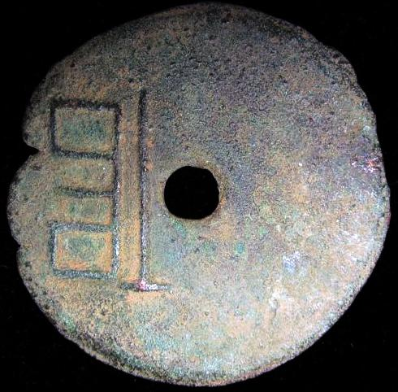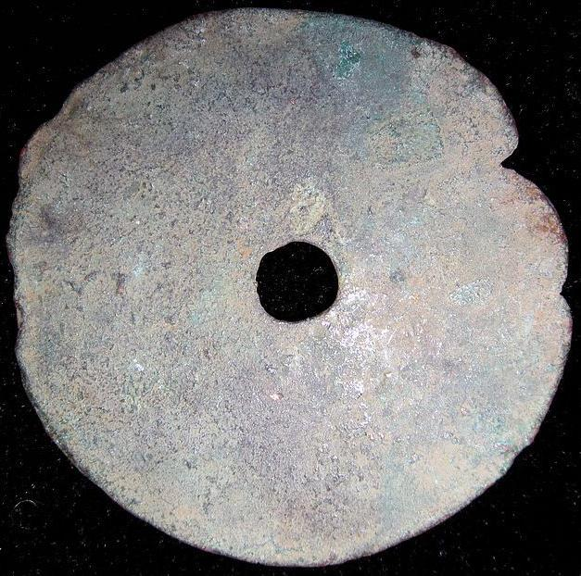

Yuan, City in the state of Liang, Inscription reversed of H 6.3, Ref: DCD 614, FD 358, H 6.4 R 7

垣圜钱,"Yuan"Coin.A Coin which was made & used in the Wei Nation(403-225BC),warring states period."垣"Place of Wei Nation.

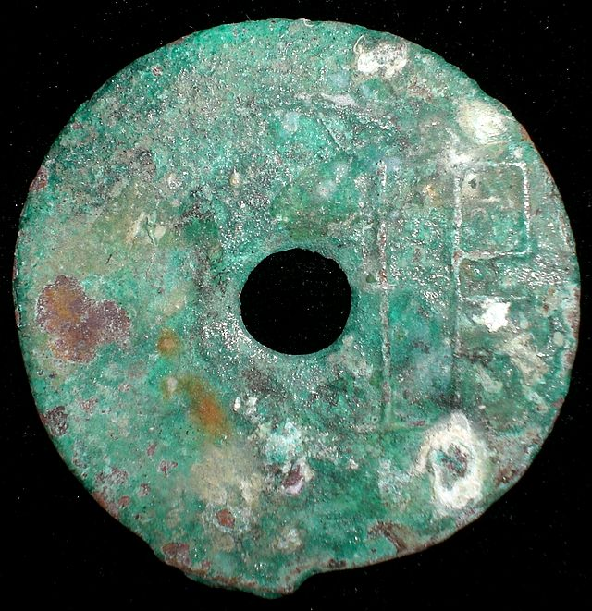

H 6.3

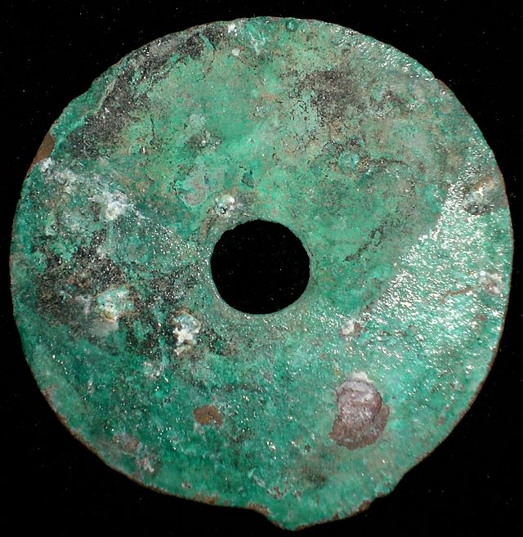

H 6.3

垣圜钱,"Yuan" Coin. A Coin which was made and used in the Wei Nation(403-225BC),warring states period."垣"Place of Wei Nation. Dia. 4 cm. / 1.57 in.

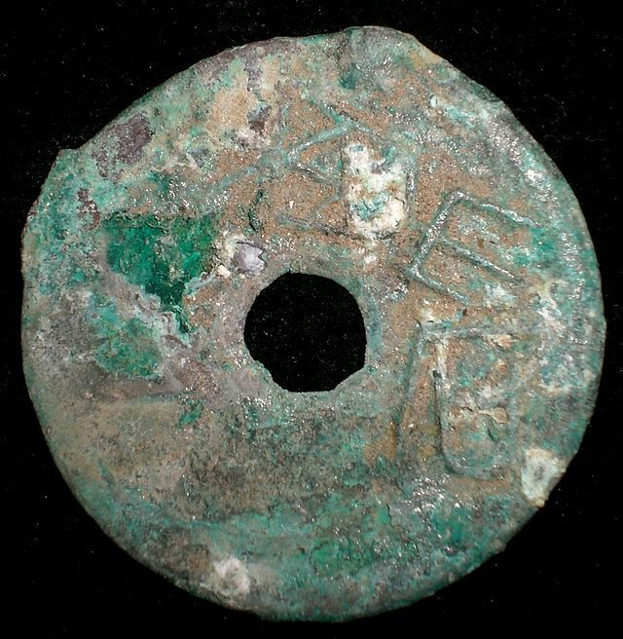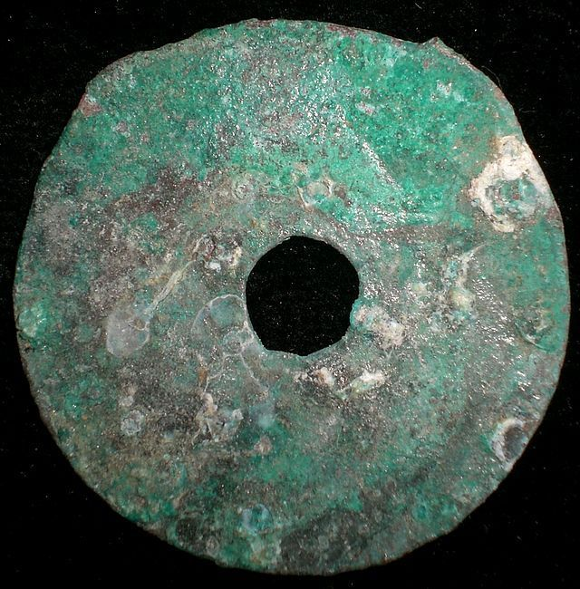

离石圜钱,"LiShi"Coin. A Coin which was made and used in the Zhao Nation (403-222BC),warring states period."LiShi",place.Besides the round coin,the Spade-shape LiShi Coin was found recently. Dia. 3.7cm. /1.46 in.

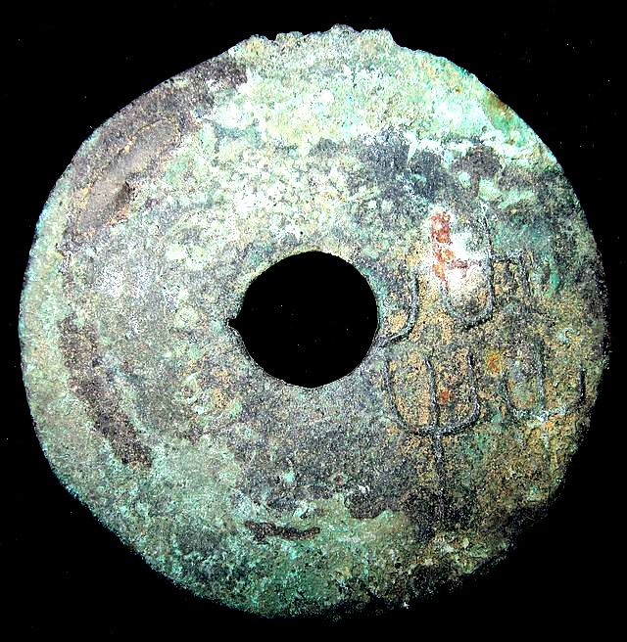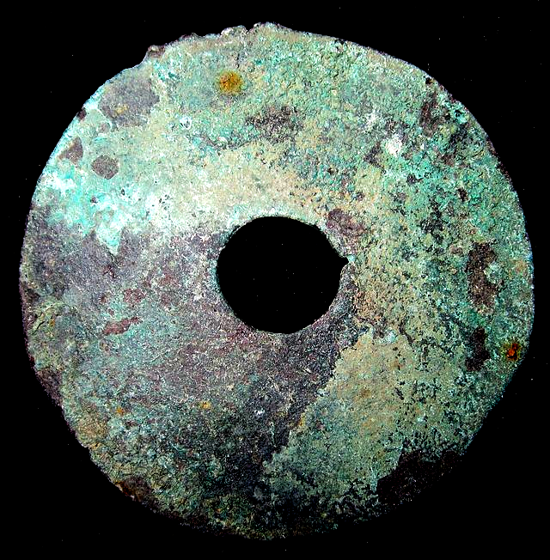

6.1

共圜钱,"Gong"Coin.A Coin which was made and used in the Wei Nation (403-225BC), Warring States Period."共"Place of Wei Nation. Dia. 4.4 cm. /1.73 in.

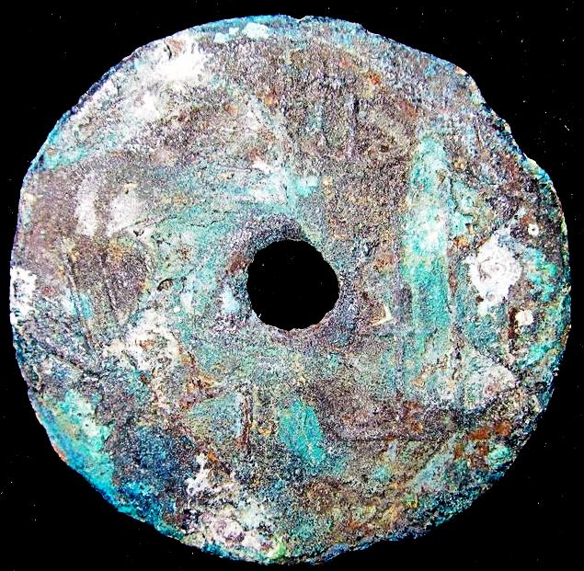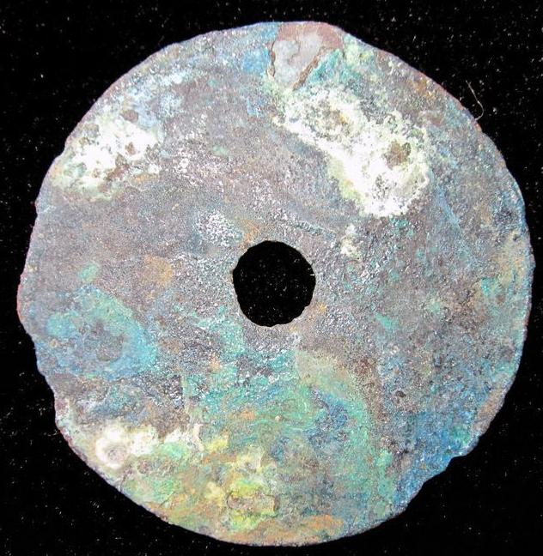

桼垣一釿,"Qi Yuan Yi Jin" Coin. A Coin which was made and used in the Wei Nation (403-225BC), Warring States Period."桼垣"Place of Wei Nation,"一釿" was weight (about 15gm.) which amount of "一两"in Qin Nation. So, It could be change with 2 Ban Liang Coin in Qin Nation. It records that there are 4 coins in the Qi Yuan Place:"桼垣一釿","桼圜一釿","桼圃半釿"and"半圜". Dia. 3.8 cm. /1.50 in.

Lacouperie 153.Tch'ang-

yuen

yh

kin

"One kin of Tch'ang-yuen.` Tch'ang-yuen was in the North-east of the modern hien of the same name (lat 35o 18', long . 114o 56', in tchili. The same type was severally issued with small differences." Lacouperie 1892: 325

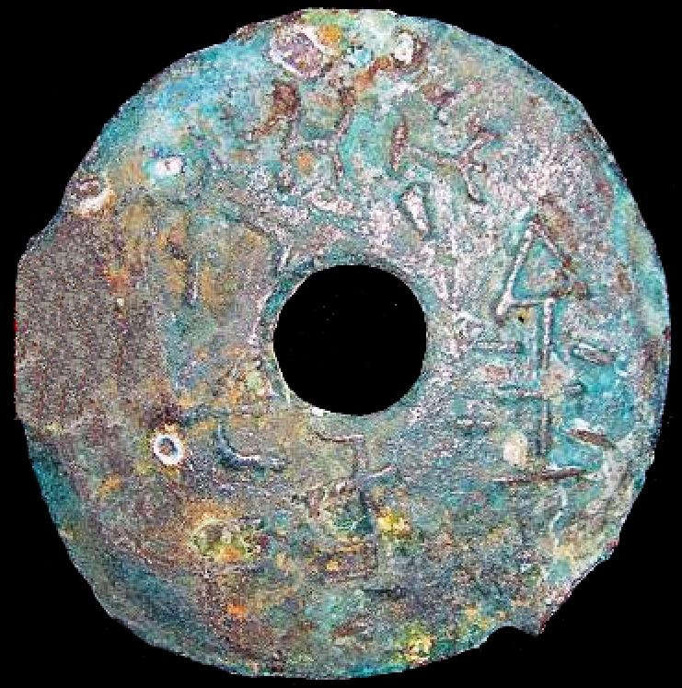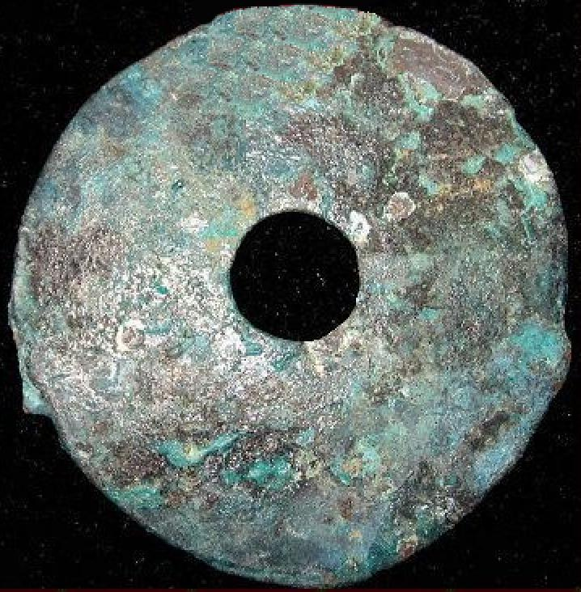

共屯赤金,"GongTunChiJin"Coin.A Coin which was made&used in the Wei Nation(403-225BC),Middle&Late warring states period."共屯"Also called"共",Place of Wei Nation;"赤金"means it was made of red medal. 4.1CM/1.61Inches